Q1. Find out the mail servers of the following:

1.WIPRO.COM
Ans. Ist -Open the CMD (Command Prompt) in window machine by clicking WIN+R (Run Command) then search CMD, as follow:-

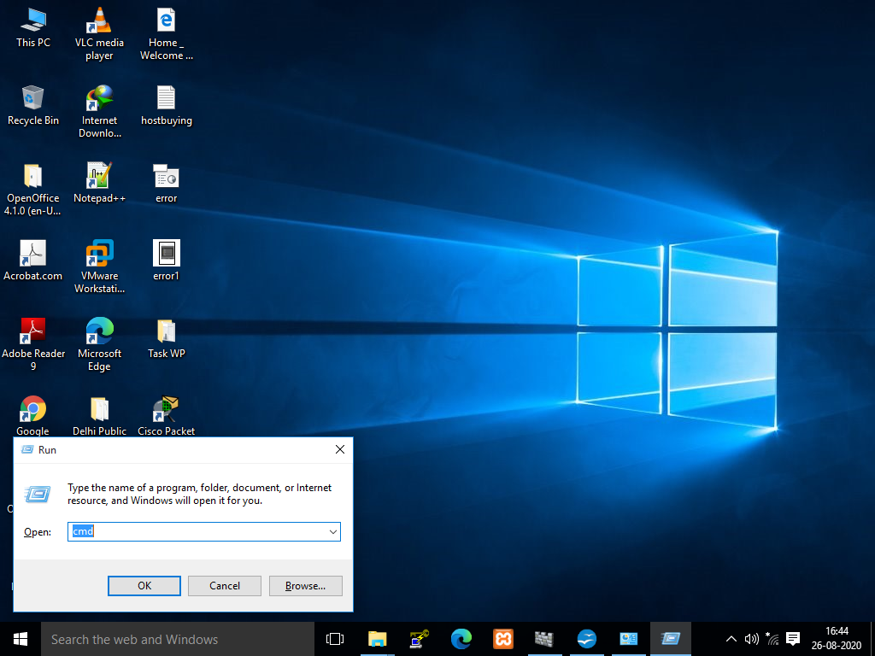

2nd- Then Type “nslookup” in CMD:-
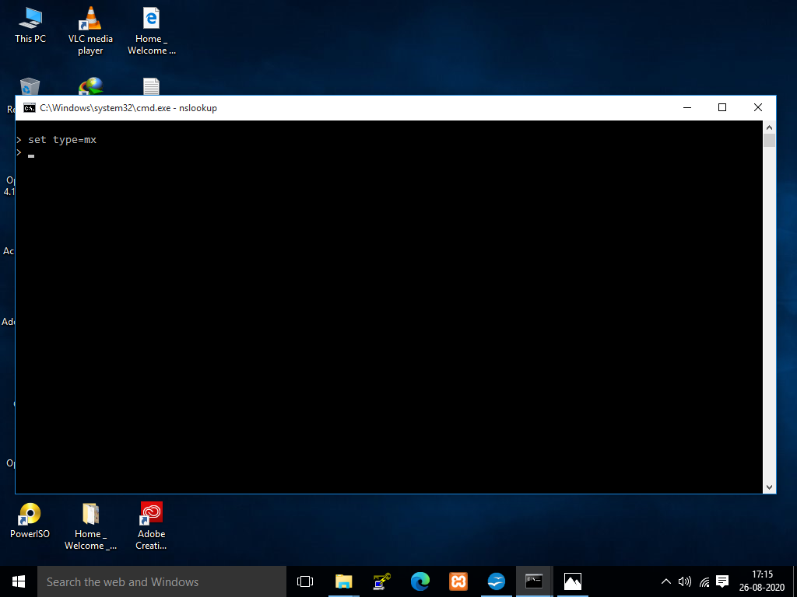
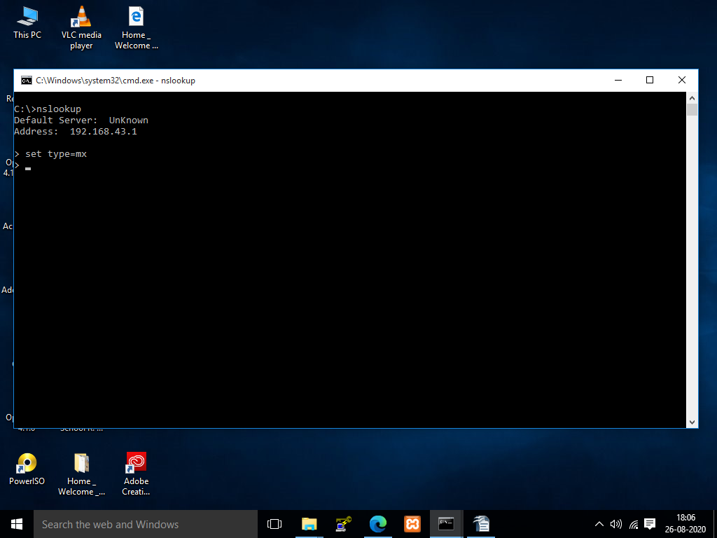

Made by:- Abhishek Kumar

3rd- Then type “set type=mx”.
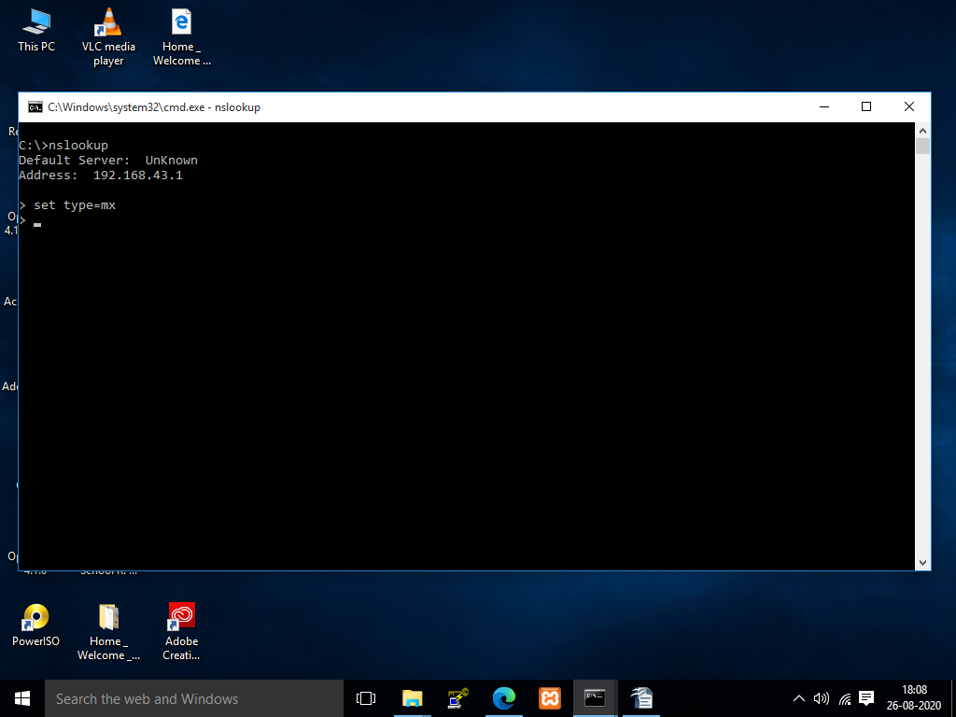

4th- Then enter the URL of particular website to find the mail server “www.wipro.com
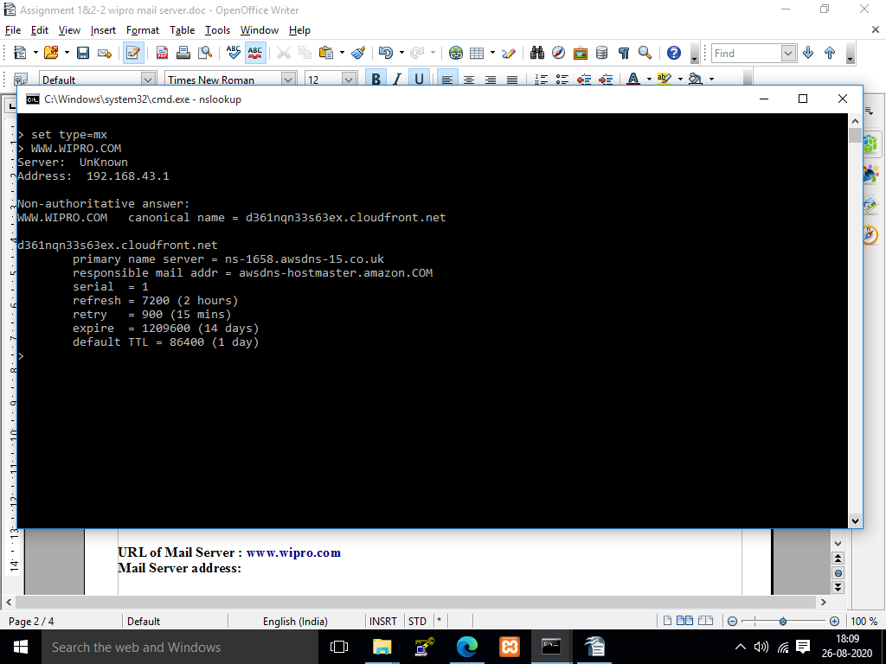

Made by:- Abhishek Kumar

URL of Mail Server : www.wipro.com
Mail Server address: awsdns-hostmaster.amazon.COM

Q2. Location where the mail servers are hosted.

URL: www.wipro.com
Location of twhe mail server is:-
Country : UNITED STATES
City : RENO

Ist – Go to the google chrome & search for “WHOIS DOMAIN LOOKUP” or direct type in URL “www.whois.com/whois”.
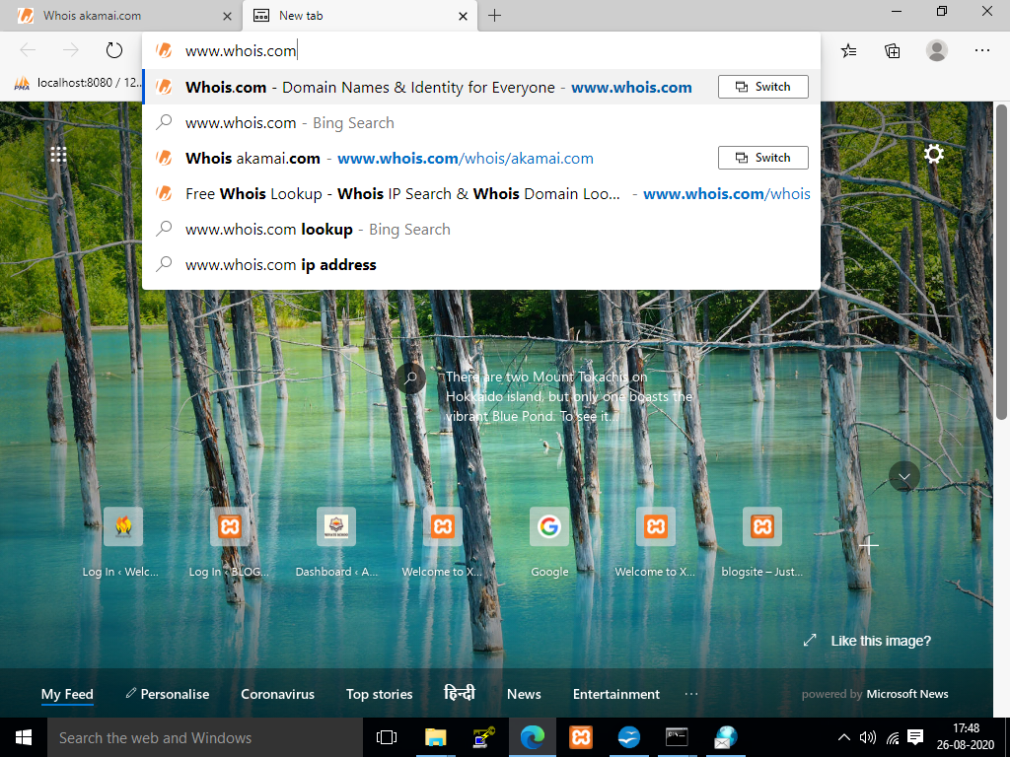
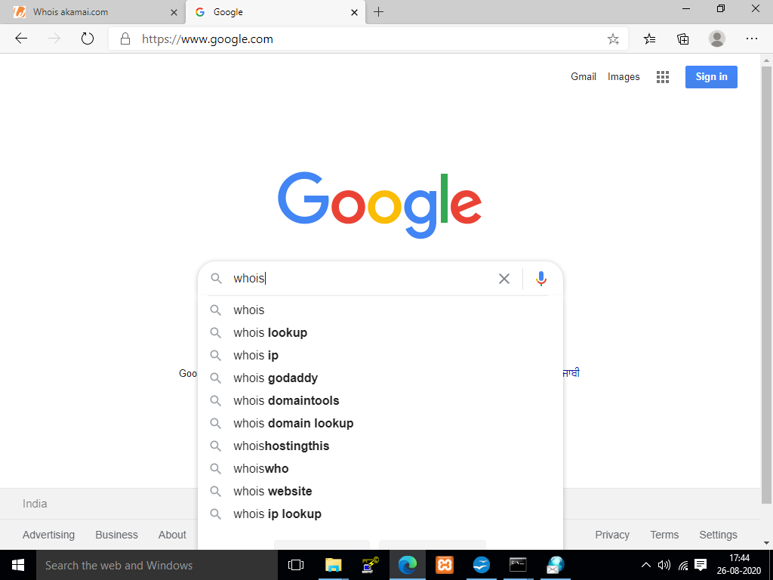

Made by:- Abhishek Kumar

2nd- Then Serach the “mail server address” in serach bar.

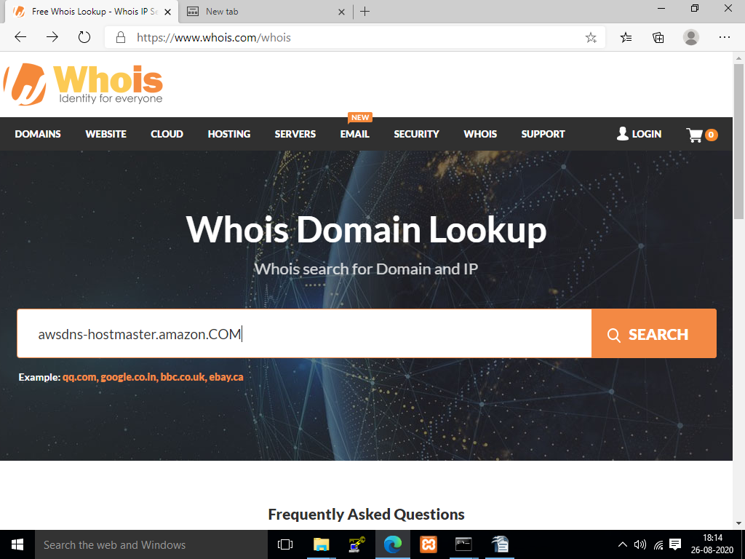

3rd- The result will shown as below:-
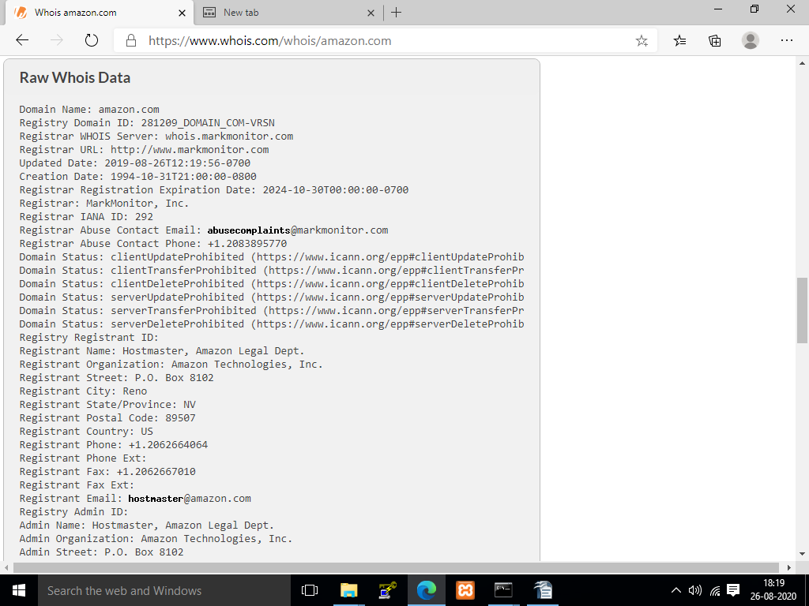
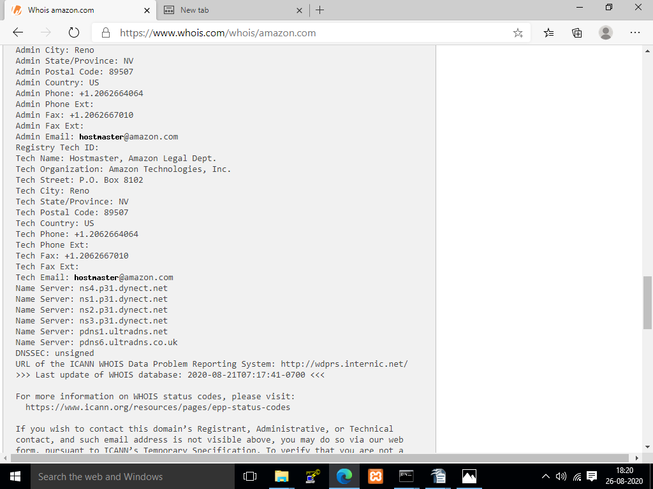

Made by:- Abhishek Kumar
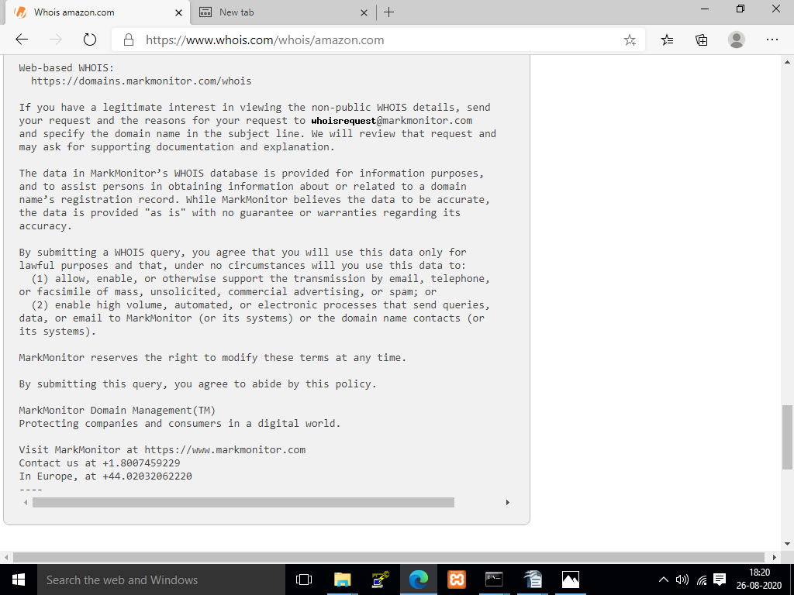

Made by:- Abhishek Kumar

